SESSION 13 ASSIGNMENT 2

**Problem**:

A Fibonacci series (starting from 1) written in order without any spaces in between, thus

producing a sequence of digits.

Write a Scala application to find the Nth digit in the sequence.

Write the function using standard for loop

**Code**:

package Assignment_13

import scala.collection.mutable.ListBuffer

class fib(a:Int) {

var first = 0

var last = 0

var temp = 0

var A = new ListBuffer[Int]()

*//Using for loop to populate list with fibonnaci series numbers till the entered nth number*

for (x <- 1 to a) {

if (x == 1) {

last=1

A += 1

}

else {

temp = first + last

A += temp

first = last

last = temp

}

}

def printfib():Unit={

println("Fibonacci series for " + a + "th term is " + A.toList.mkString(""))

}

}

object fiblist extends App {

var new1 = new fib(2).printfib()

var new2 = new fib(13).printfib()

var new3 = new fib(5).printfib()

var new4 = new fib(20).printfib()

}

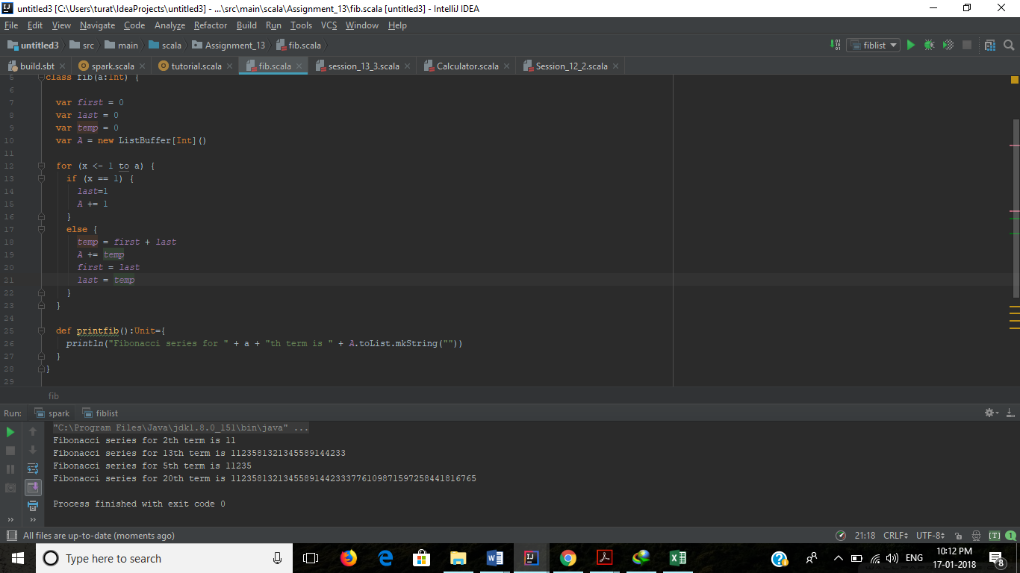

**Output**:

Fibonacci series for 2th term is 11

Fibonacci series for 13th term is 1123581321345589144233

Fibonacci series for 5th term is 11235

Fibonacci series for 20th term is 11235813213455891442333776109871597258441816765

Process finished with exit code 0

Write the function using recursion

**Code**:

package Assignment_13

import scala.collection.mutable.ListBuffer

class fib_rec (a:Int) {

var temp =0

var A = new ListBuffer[Int]()

A += 0

A += 1

*//Retriving first value of list A*

fibonacci(A.head)

//Using Recursion method to populate fibonnaci series terms into list

def fibonacci(last:Int): Unit = {

if (a >= (A.length)) {

temp = A.last

A += (A.last + last)

fibonacci(temp)

}

}

println("Fibonacci series till " + a + "th term is : " + A.drop(1).mkString(""))

}

object exec_fib_rec extends App{

var result = new fib_rec(2)

var result1 = new fib_rec(13)

var result2 = new fib_rec(5)

var result3 = new fib_rec(20)

}

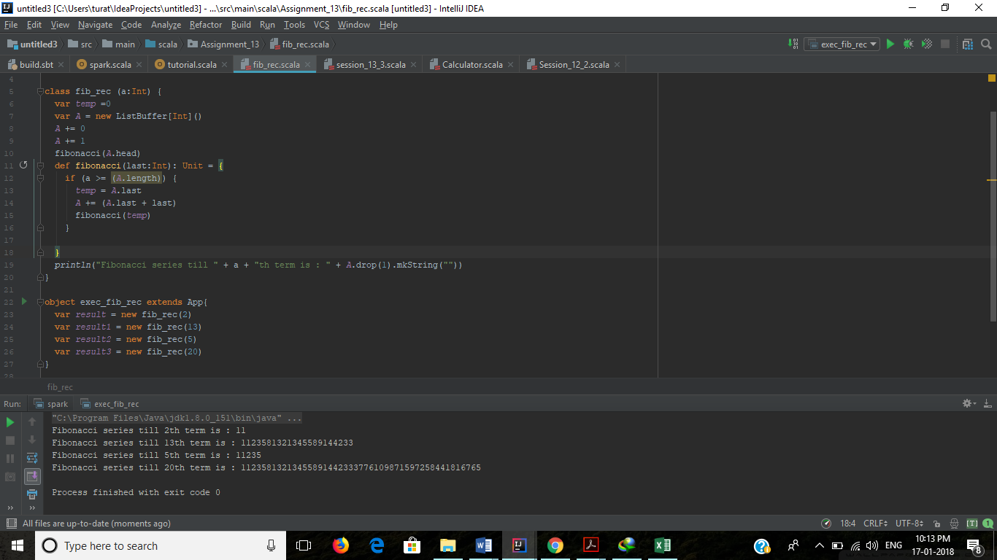

**Output**:

Fibonacci series till 2th term is : 11

Fibonacci series till 13th term is : 1123581321345589144233

Fibonacci series till 5th term is : 11235

Fibonacci series till 20th term is : 11235813213455891442333776109871597258441816765

Process finished with exit code 0